**Day 3 of Remote Sensing**

* **Mosic Dataset Rasters**

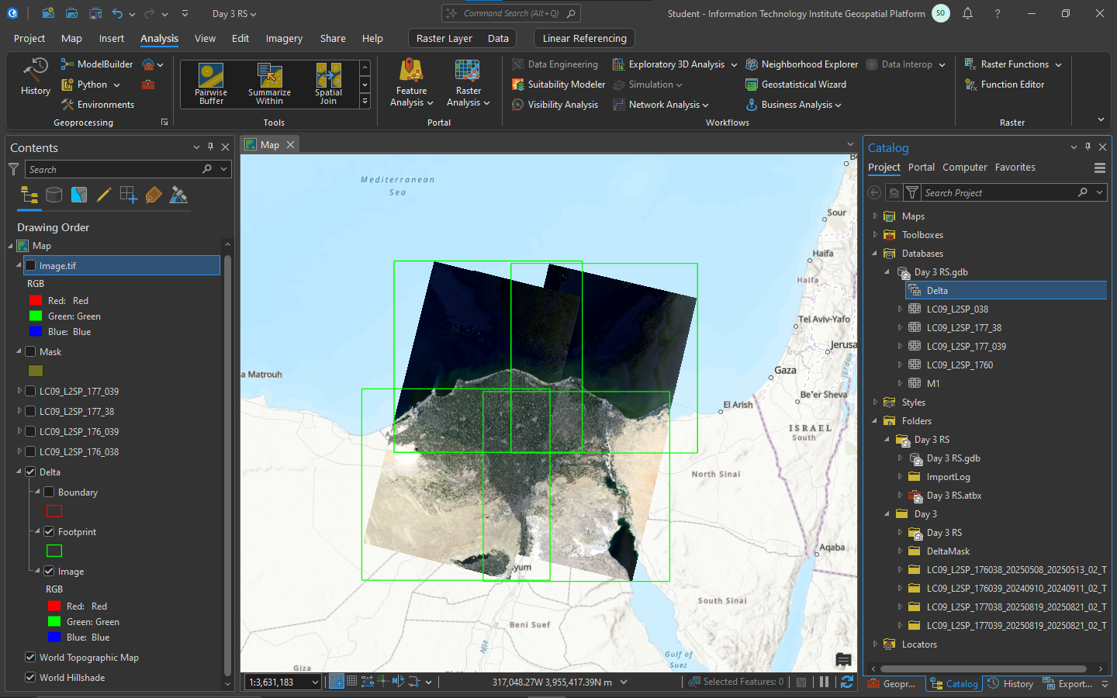

* **Clip the mask and the Mosic Dataset**

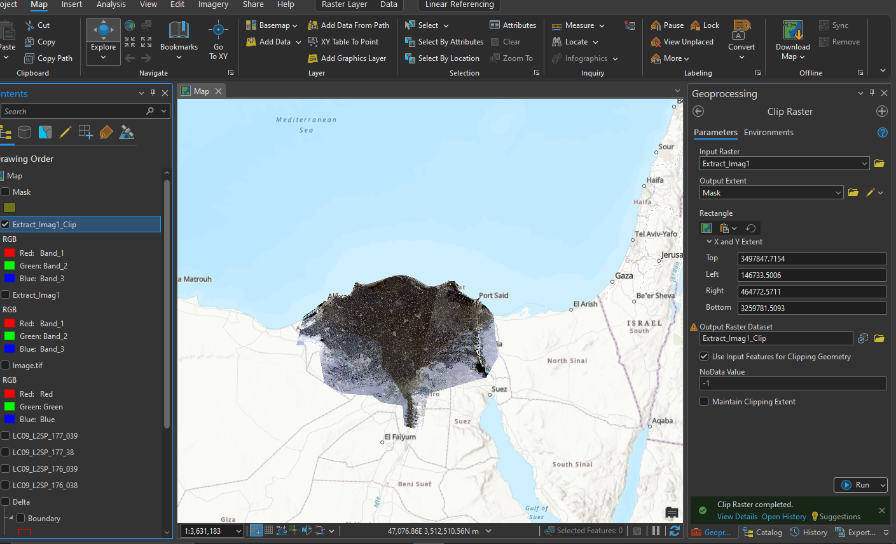

* **NDVI Calculation**

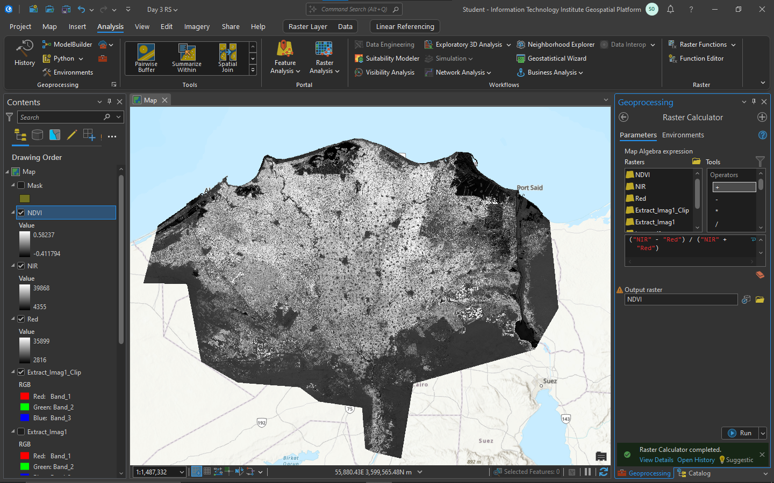

* **NDVI with color Ramp**

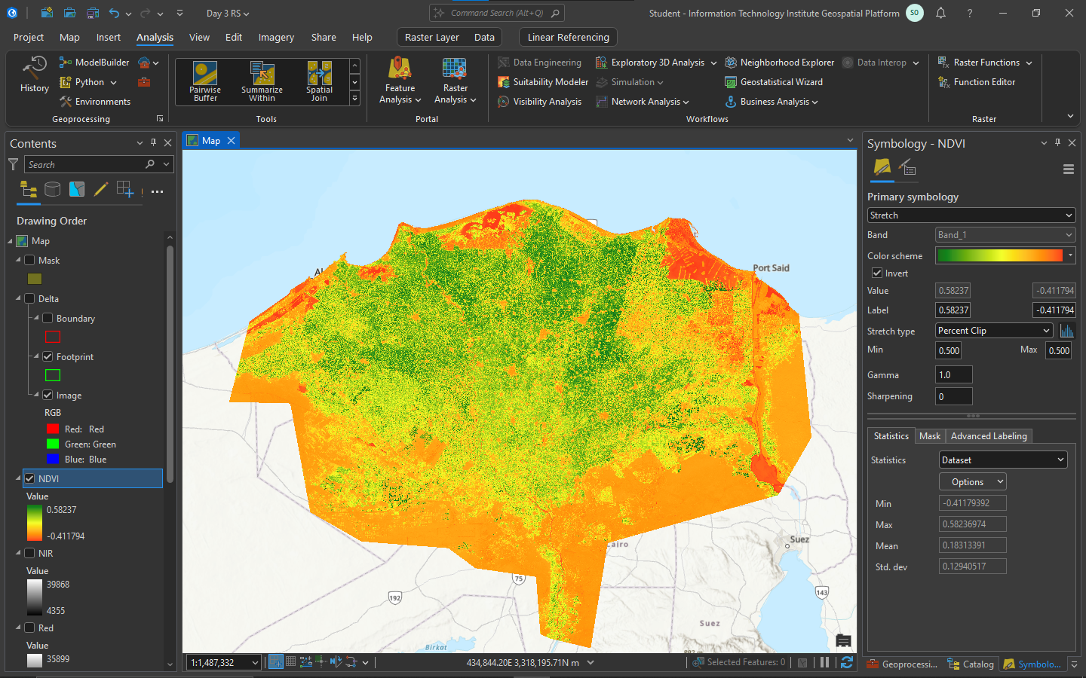

* **Extract the good plants from 0.4**

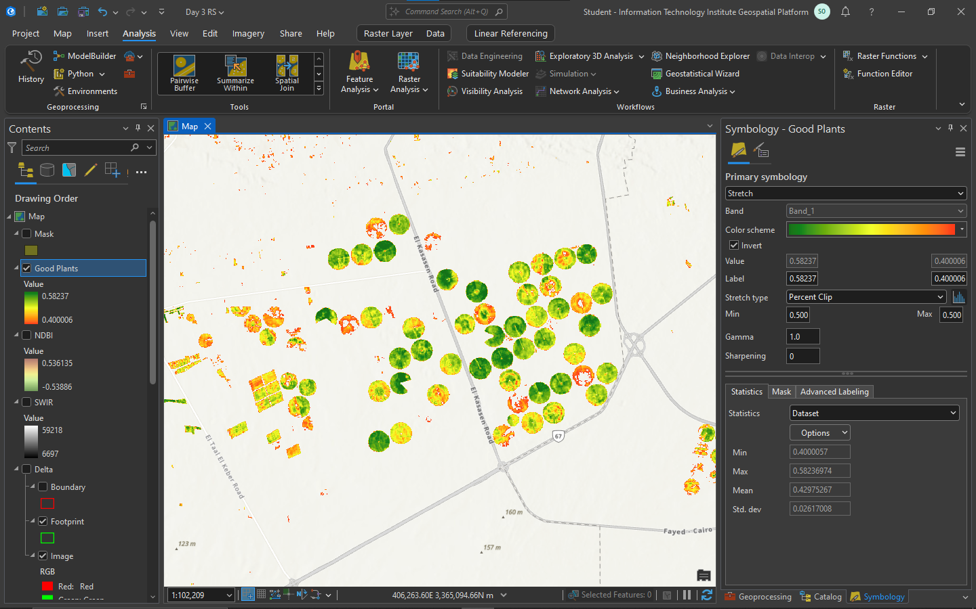

* **NDBI Calc and Color Plot**

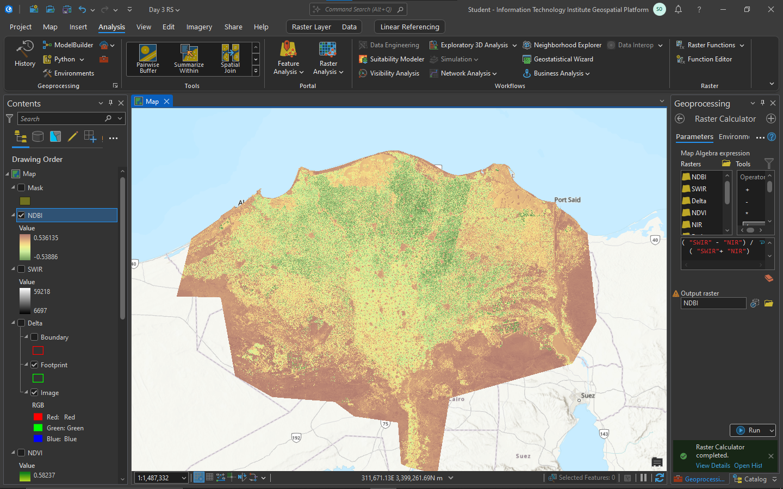

* **NDWI**

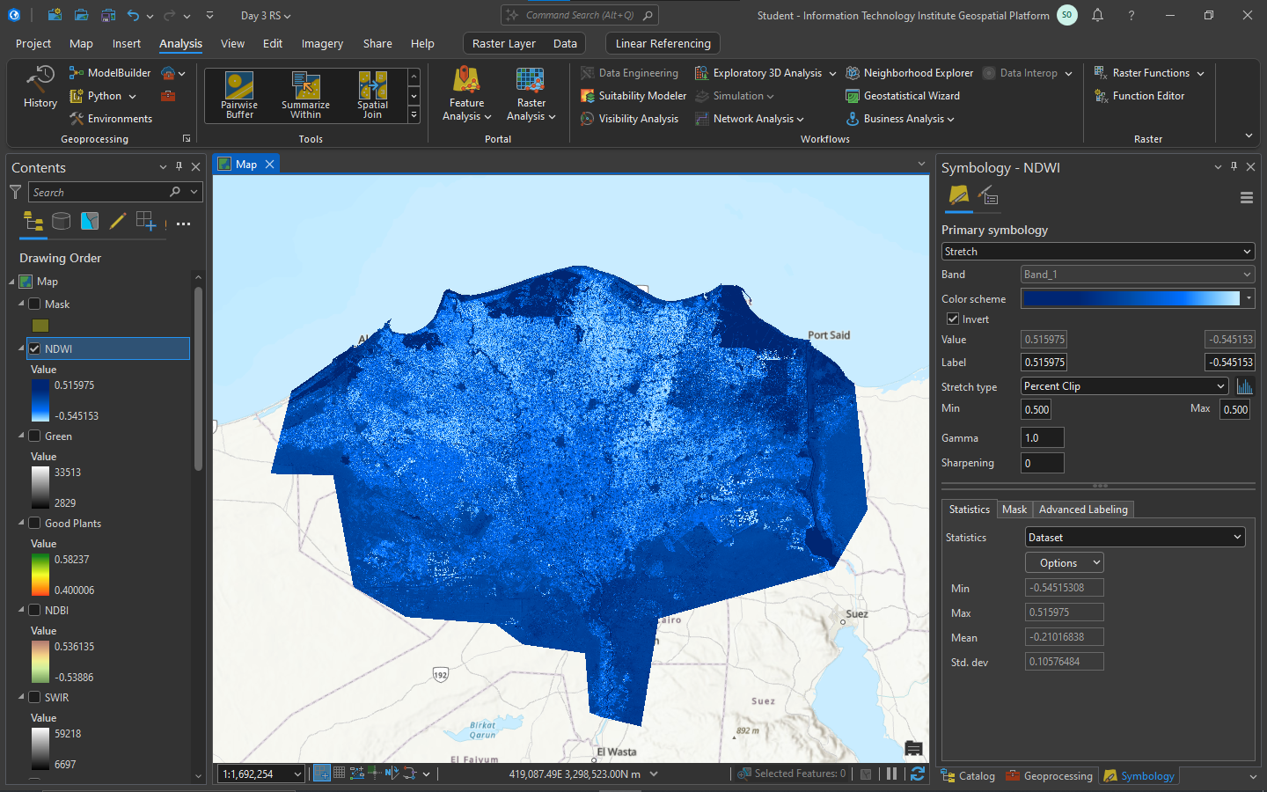

* **LST**

